**Practical No.4**

Binomial Distribution

Name: Neeraj Sanjay Shah

Roll no: 51

Class: F.Y Data Science

Sub: Probability & Distribution

Sign:

**AIM: To compute binomial distribution of random variable.**

Q.1 A fair coin is tossed 10 times, what are the probability of getting exactly 6 heads and at least six heads.

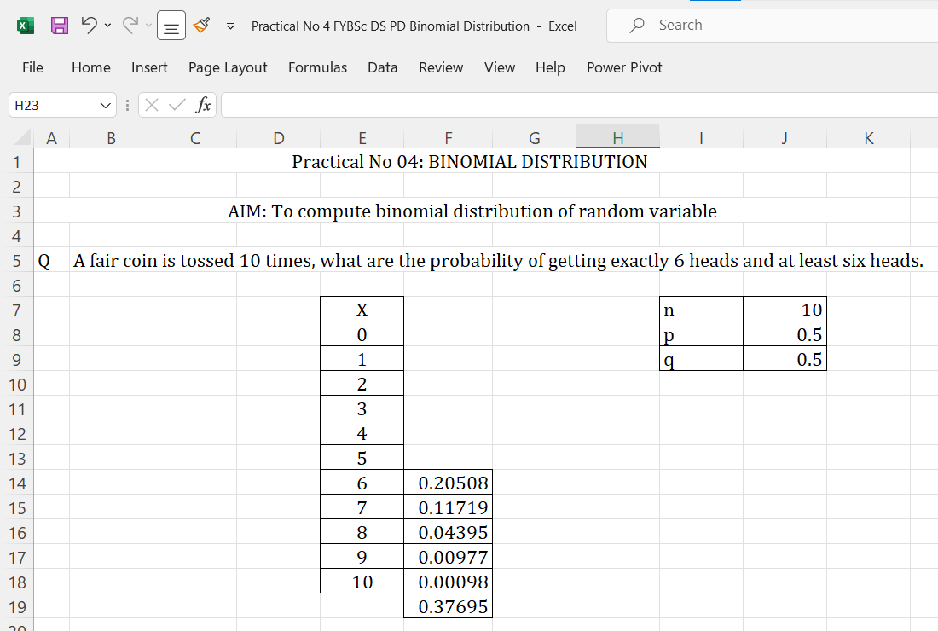

Q.2 If a coin is tossed 5 times, find the probability of:

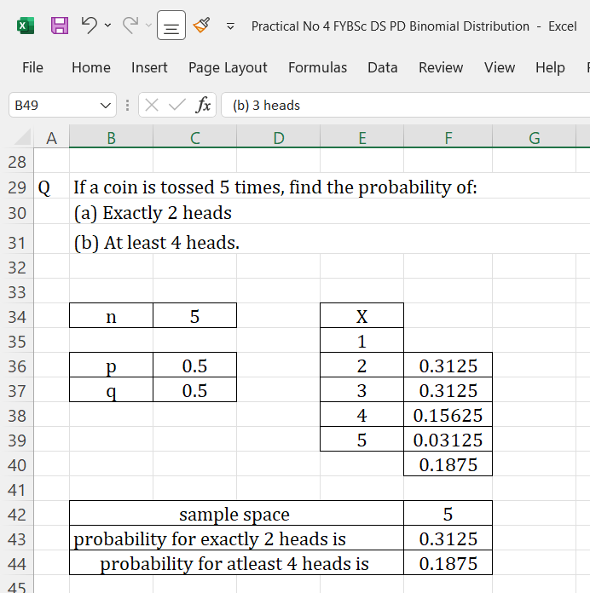

Q.3 An unbiased coin is tossed 6 times. Find the probability of getting

(a) at least 4 heads

(b) 3 heads

